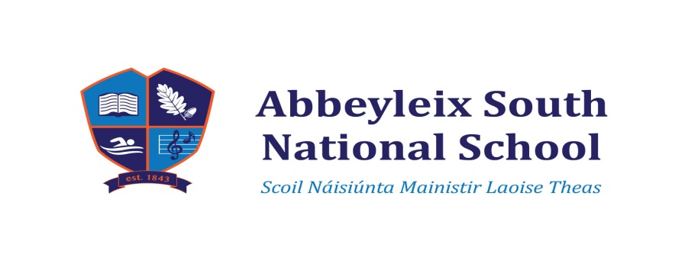
Sixth Class Book List 2022 - 2023

English:
- Starlight 6th Class Combined Reading and Skills Book Folens ( Available to rent
from the school)
- Spellbound 6 Fallons
- Novel: Safe Harbour by Marita Conlon-McKenna (Available to rent from the school)
- Novel: Wonder by R. J. Palacio (Available to rent from the school)
- Dictionary
- Master your Grammar 5 C. J. Fallon
Maths:
- Mathemagic 6 Textbook Fallons (Available to rent from the school)
- Mathemagic 6 Assessment book Fallons
- Brain Teasers 6 Mental Mathematics Fallons (Available to rent from the school)
- Protractor and compass
- Calculator basic one not scientific please
- Table Book
- Master your Maths 5 C. J. Fallon

Gaeilge:
- Abair Liom G Folens (Available to rent from the school)
- Ríra 5 C. J. Fallon
- Am don léamh Rang a Sé Folens
- Irish Dictionary
S.E.S.E:
- Window on the World 5th Class Geography Edco (Available to rent from the school)
- Window on the World 5th Class History Edco (Available to rent from the school)
- Window on the World 5th Class Science Edco (Available to rent from the school)
Religious Education:
- Good News Bible
- Follow Me (Working Out) – provided by school

P.T.O.
Copies: 9 X 120 pages label: English(4) Home Spellings(1) School Spellings(1)
Irish(2) S.E.S.E(1)
5 X 88 pages label: Maths
4 X 88 pages label: Verb Test Copy/English Writing Genres/Creative Writing/
Religion
1 A4 Hardback: Study Notes
1 A4 Ring Binder with Polly Pockets and subject dividers

Additional Items:
Named please
- 1 X Memory Stick – named
- 1 Large Pritt Stick
- 4 Sharpie Black Outliner Markers

Pencil Case:
Name all items
- 2 Staedtler handwriting pen 309 blue
- Pencils
- Sharpener
- Ruler
- Erasers
- Red biros
- Colouring pencils/markers
Please also send in a 2 Pack of Kitchen Towels

Money to be Transferred to the school account by Wednesday 31st August
Bank Details: Account Name – Abbeyleix South National School
IBAN – IE28BOFI90159719765345
Bank of Ireland
Abbeyleix
Please put in in the Reference section “Name and what Payment is for”

€25.00 towards ink, paper, photocopying expenses (worksheets etc. )
€25.00 towards Art Supplies for the year
---------

€50.00

Thank you. P.T.O.

