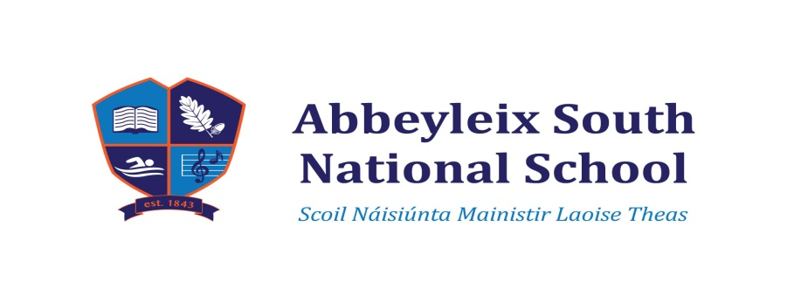
Junior Infant Book List 2022 – 2023
Maths: Busy at Maths – Junior Infants Pack – C.J. Fallon
English: Rainbow Core Book 1 for Junior Infants ‘New Friends’ C.J. Fallon
Rainbow Core Book 2 for Junior Infants ‘Fun at Home’ C.J. Fallon
Rainbow Core Book 3 for Junior Infants ‘Fun at the Park’ C.J. Fallon
Just Phonics Junior Infants 26 Letter sounds Educate.ie
Ready to Write A1 (cursive) Edco.

Irish: Oral Work – No book required

S.E.S.E (History, Geography and Science): Thematic Approach to S.E.S.E – books created by teacher covering all strands of the Junior Infant curriculum

Religious Education: Follow Me Programme – On our Way – available at school

Copybooks & Folders for the year:
3 Project Copies No 15 – top blank, bottom extra wide ruled, label Phonics (1) Alphabet (1)
Reading Skills (1)
1 Maths copy 20mm, label Number Work
1 A4 envelope type plastic folder – label Worksheets
1 B4 plastic folder (zip closure) – label Homework
1 A5 plastic folder – label Library Books

Please send in all books and copies covered and clearly labelled. They will be kept in school and taken home when completed.

Stationary Items for the year: (all these items to be labelled individually please)
No Pencil Case required, tub supplied by school.
9 Junior Grip – Faber Castell pencils
3 erasers
3 packets of Crayola Twistables (with thick nib)
1 sharpener (Twin hole)
3 large pritt sticks – real Pritt brand please as it does not dry out

In one ziplock bag, place 1 eraser, 1 Junior Grip pencil, 1 set of Twistables, 1 pritt and the sharpener. Place the additional items from the list above in a second ziplock bag labelled with your child’s name.
Please note: These items will be kept in school. A similar set will be required for homework use.

Each child is asked to bring in a 4 pack of kitchen towels – they have many uses! Please ensure that your child’s school bag is big enough to hold lunchbox and B4 homework folder.

P.T.O.

Money to be Transferred to the school account by Wednesday 31st August.

Bank Details: Account Name – Abbeyleix South National School
IBAN – IE28BOFI90159719765345
Bank of Ireland
Abbeyleix
Please put in in the Reference section “Name and what Payment is for”

€25.00 towards ink, paper, photocopying expenses (worksheets etc. )
€25.00 towards Art Supplies for the year
---------

€50.00

Thank you.

P.T.O.

